ROUGH WORK FOR TICK CROSS GAME:

Try 1:

#include<iostream>

using namespace std;

void board();

void player_turn();

int row, col;

char turn = 'X';

int main()

{

while (true)

{

board();

player_turn();

board();

}

}

void player_turn()

{

int choice;

// if(turn=='X')

// cout<<"\n Player 1 [X] turn:";

// if(turn=='O')

string board[5][5] = { {"1","2","3","4","5"},{"6","7","8","9","10"},{"11","12","13","14","15"},{"16","17","18","19","20"},{"21","22","23","24","25"} };

system("cls");

cout << board[0][0] << "\t" << board[0][1] << "\t" << board[0][2] << "\t" << board[0][3] << "\t" << board[0][4] << "\n";

cout << board[1][0] << "\t" << board[1][1] << "\t" << board[1][2] << "\t" << board[1][3] << "\t" << board[1][4] << "\n";

cout << board[2][0] << "\t" << board[2][1] << "\t" << board[2][2] << "\t" << board[2][3] << "\t" << board[2][4] << "\n";

cout << board[3][0] << "\t" << board[3][1] << "\t" << board[3][2] << "\t" << board[3][3] << "\t" << board[3][4] << "\n";

cout << board[4][0] << "\t" << board[4][1] << "\t" << board[4][2] << "\t" << board[4][3] << "\t" << board[4][4] << "\n";

cout << "\n Player 1 [X] turn:";

cin >> choice;

switch (choice)

{

case 1:row = 0; col = 0; break;

case 2:row = 0; col = 1; break;

case 3:row = 0; col = 2; break;

case 4:row = 0; col = 3; break;

case 5:row = 0; col = 4; break;

case 6:row = 1; col = 0; break;

case 7:row = 1; col = 1; break;

case 8:row = 1; col = 2; break;

case 9:row = 1; col = 3; break;

case 10:row = 1; col = 4; break;

case 11:row = 2; col = 0; break;

case 12:row = 2; col = 1; break;

case 13:row = 2; col = 2; break;

case 14:row = 2; col = 3; break;

case 15:row = 2; col = 4; break;

case 16:row = 3; col = 0; break;

case 17:row = 3; col = 1; break;

case 18:row = 3; col = 2; break;

case 19:row = 3; col = 3; break;

case 20:row = 3; col = 4; break;

case 21:row = 4; col = 0; break;

case 22:row = 4; col = 1; break;

case 23:row = 4; col = 2; break;

case 24:row = 4; col = 3; break;

case 25:row = 4; col = 4; break;

default:

cout << "Invalid Choice.....";

break;

}

if (turn == 'X')

{

board[row][col] = 'X';

cout << board[row][col];

turn = 'O';

}

else if (turn == 'O')

{

board[row][col] = 'O';

cout << board[row][col];

turn = 'X';

}

}

void board()

{

string board[5][5] = { {"1","2","3","4","5"},{"6","7","8","9","10"},{"11","12","13","14","15"},{"16","17","18","19","20"},{"21","22","23","24","25"} };

system("cls");

cout << board[0][0] << "\t" << board[0][1] << "\t" << board[0][2] << "\t" << board[0][3] << "\t" << board[0][4] << "\n";

cout << board[1][0] << "\t" << board[1][1] << "\t" << board[1][2] << "\t" << board[1][3] << "\t" << board[1][4] << "\n";

cout << board[2][0] << "\t" << board[2][1] << "\t" << board[2][2] << "\t" << board[2][3] << "\t" << board[2][4] << "\n";

cout << board[3][0] << "\t" << board[3][1] << "\t" << board[3][2] << "\t" << board[3][3] << "\t" << board[3][4] << "\n";

cout << board[4][0] << "\t" << board[4][1] << "\t" << board[4][2] << "\t" << board[4][3] << "\t" << board[4][4] << "\n";

}

Output and error of this program:

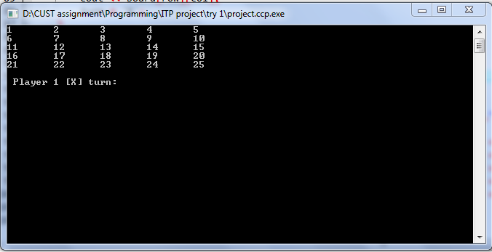

Try 2:

#include<iostream>

using namespace std;

char board[5][5] = { {'1','2','3','4','5'},{'6','7','8','9','10'},{'11','12','13','14','15'},{'16','17','18','19','20'},{'21','22','23','24','25'} };

void layout_game();

int main()

{

int choice, k;

system("COLOR 97");

cout << "\tTick Cross Game";

cout << "\n\tPlayer1 [X] \n\tPlayer2 [O]\n\n";

for (k = 1; k <=25; k++)

{

layout_game();

cout << "\n\tPlayer1 [X] turn:";

cin >> choice;

if (k == 5)

exit(0);

switch (choice)

{

case 1:

board[0][0] = 'X';

break;

case 2:

board[0][1] = 'X';

break;

case 3:

board[0][2] = 'X';

break;

case 4:

board[1][0] = 'X';

break;

case 5:

board[1][1] = 'X';

break;

case 6:

board[1][2] = 'X';

break;

case 7:

board[2][0] = 'X';

break;

case 8:

board[2][1] = 'X';

break;

default:

board[2][2] = 'X';

break;

}

layout_game();

cout << "\n\tPlayer2 [O] turn:";

cin >> choice;

switch (choice)

{

case 1:

board[0][0] = 'O';

break;

case 2:

board[0][1] = 'O';

break;

case 3:

board[0][2] = 'O';

break;

case 4:

board[1][0] = 'O';

break;

case 5:

board[1][1] = 'O';

break;

case 6:

board[1][2] = 'O';

break;

case 7:

board[2][0] = 'O';

break;

case 8:

board[2][1] = 'O';

break;

default:

board[2][2] = 'O';

break;

}

}

return 0;

}

void layout_game()

{

cout << "\t\t_____________________________\n";

cout << "\t\t\b| | | | |\n";

cout << "\t\t\b|" << board[0][0] << " |" << "\t" << board[0][1] << " |" << "\t" << board[0][2] << "|" << " " << board[0][3] << " | " << board[0][4] << "\n";

cout << "\t\t\b|_____|_____|_____|_____|_____\n";

cout << "\t\t\b| | | | |\n";

cout << "\t\t\b|" << board[1][0] << " |" << "\t" << board[1][1] << " |" << "\t" << board[1][2] << "|" << " " << board[1][3] << " | " << board[1][4] << "\n";

cout << "\t\t\b|_____|_____|_____|_____|_____\n";

cout << "\t\t\b| | | | |\n";

cout << "\t\t\b|" << board[2][0] << " |" << "\t" << board[2][1] << " |" << "\t" << board[2][2] << "|" << " " << board[2][3] << " | " << board[2][4] << "\n";

cout << "\t\t\b|_____|_____|_____|_____|_____\n";

cout << "\t\t\b| | | | |\n";

cout << "\t\t\b|" << board[3][0] << " |" << "\t" << board[3][1] << " |" << "\t" << board[3][2] << "|" << " " << board[3][3] << " | " << board[3][4] << "\n";

cout << "\t\t\b|_____|_____|_____|_____|_____\n";

cout << "\t\t\b| | | | |\n";

cout << "\t\t\b|" << board[4][0] << " |" << "\t" << board[4][1] << " |" << "\t" << board[4][2] << "|" << " " << board[4][3] << " | " << board[4][4] << "\n";

cout << "\t\t\b|_____________________________\n";

}

Output of this program and Error:

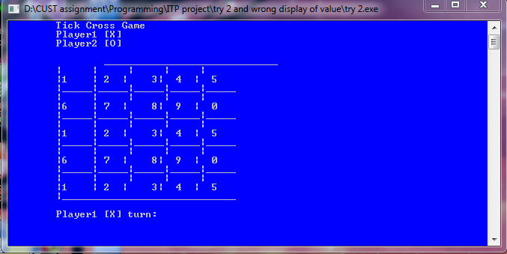

TRY 3 (3 BY 3 GAME):

#include <iostream>

using namespace std;

char square[10] = { 'o','1','2','3','4','5','6','7','8','9' };

int checkwin();

void board();

int main()

{

int player = 1, i, choice;

char mark;

do

{

board();

player = (player % 2) ? 1 : 2;

cout << "Player " << player << ", enter a number: ";

cin >> choice;

mark = (player == 1) ? 'X' : 'O';

if (choice == 1 && square[1] == '1')

square[1] = mark;

else if (choice == 2 && square[2] == '2')

square[2] = mark;

else if (choice == 3 && square[3] == '3')

square[3] = mark;

else if (choice == 4 && square[4] == '4')

square[4] = mark;

else if (choice == 5 && square[5] == '5')

square[5] = mark;

else if (choice == 6 && square[6] == '6')

square[6] = mark;

else if (choice == 7 && square[7] == '7')

square[7] = mark;

else if (choice == 8 && square[8] == '8')

square[8] = mark;

else if (choice == 9 && square[9] == '9')

square[9] = mark;

else

{

cout << "Invalid move ";

player--;

cin.ignore();

cin.get();

}

i = checkwin();

player++;

} while (i == -1);

board();

if (i == 1)

cout << "==>\aPlayer " << --player << " win ";

else

cout << "==>\aGame draw";

cin.ignore();

cin.get();

return 0;

}

/*********************************************

FUNCTION TO RETURN GAME STATUS

1 FOR GAME IS OVER WITH RESULT

-1 FOR GAME IS IN PROGRESS

O GAME IS OVER AND NO RESULT

**********************************************/

int checkwin()

{

if (square[1] == square[2] && square[2] == square[3])

return 1;

else if (square[4] == square[5] && square[5] == square[6])

return 1;

else if (square[7] == square[8] && square[8] == square[9])

return 1;

else if (square[1] == square[4] && square[4] == square[7])

return 1;

else if (square[2] == square[5] && square[5] == square[8])

return 1;

else if (square[3] == square[6] && square[6] == square[9])

return 1;

else if (square[1] == square[5] && square[5] == square[9])

return 1;

else if (square[3] == square[5] && square[5] == square[7])

return 1;

else if (square[1] != '1' && square[2] != '2' && square[3] != '3'

&& square[4] != '4' && square[5] != '5' && square[6] != '6'

&& square[7] != '7' && square[8] != '8' && square[9] != '9')

return 0;

else

return -1;

}

/*******************************************************************

FUNCTION TO DRAW BOARD OF TIC TAC TOE WITH PLAYERS MARK

********************************************************************/

void board()

{

system("cls");

cout << "\n\n\tTic Tac Toe\n\n";

cout << "Player 1 (X) - Player 2 (O)" << endl << endl;

cout << endl;

cout << " | | " << endl;

cout << " " << square[1] << " | " << square[2] << " | " << square[3] << endl;

cout << "_____|_____|_____" << endl;

cout << " | | " << endl;

cout << " " << square[4] << " | " << square[5] << " | " << square[6] << endl;

cout << "_____|_____|_____" << endl;

cout << " | | " << endl;

cout << " " << square[7] << " | " << square[8] << " | " << square[9] << endl;

cout << " | | " << endl << endl;

}

/*******************************************************************

END OF PROJECT

********************************************************************/

OUTPUT:

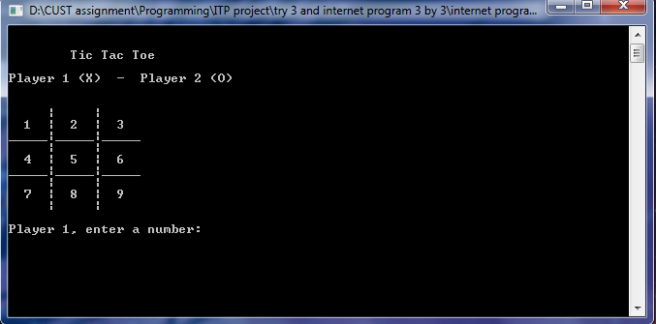

TRY 4:

#include<iostream>

using namespace std;

int main()

{

int choice,k;

char board[5][5] = { {'1','2','3','4','5'},{'6','7','8','9','10'},{'11','12','13','14','15'},{'16','17','18','19','20'},{'21','22','23','24','25'} };

cout << "\tTick Cross Game";

cout << "\n\tPlayer1 [X] \n\tPlayer2 [0]\n\n";

for (k = 1; k <= 5; k++)

{

cout << "\t\t | | | |\n";

cout << "\t\t" << board[0][0] << " |" << "\t" << board[0][1] << " |" << "\t" << board[0][2] <<"|"<<" "<< board[0][3] << " | " << board[0][4] << "\n";

cout << "\t\t_____|_____|_____|_____|_____\n";

cout << "\t\t | | | |\n";

cout << "\t\t" << board[1][0] << " |" << "\t" << board[1][1] << " |" << "\t" << board[1][2] <<"|"<<" "<< board[1][3] << " | " << board[1][4] << "\n";

cout << "\t\t_____|_____|_____|_____|_____\n";

cout << "\t\t | | | |\n";

cout << "\t\t" << board[2][0] << " |" << "\t" << board[2][1] << " |" << "\t" << board[2][2] <<"|"<<" "<< board[2][3] << " | " << board[2][4] << "\n";

cout << "\t\t_____|_____|_____|_____|_____\n";

cout << "\t\t | | | |\n";

cout << "\t\t" << board[3][0] << " |" << "\t" << board[3][1] << " |" << "\t" << board[3][2] <<"|"<<" "<< board[3][3] << " | " << board[3][4] << "\n";

cout << "\t\t_____|_____|_____|_____|_____\n";

cout << "\t\t | | | |\n";

cout << "\t\t" << board[4][0] << " |" << "\t" << board[4][1] << " |" << "\t" << board[4][2] <<"|"<<" "<< board[4][3] << " | " << board[4][4] << "\n";

cout << "\n\tPlayer1 [X] turn:";

cin >> choice;

if (k == 5)

exit(0);

switch (choice)

{

case 1:

board[0][0] = 'X';

break;

case 2:

board[0][1] = 'X';

break;

case 3:

board[0][2] = 'X';

break;

case 4:

board[1][0] = 'X';

break;

case 5:

board[1][1] = 'X';

break;

case 6:

board[1][2] = 'X';

break;

case 7:

board[2][0] = 'X';

break;

case 8:

board[2][1] = 'X';

break;

default:

board[2][2] = 'X';

break;

}

cout << "\t\t | | | |\n";

cout << "\t\t" << board[0][0] << " |" << "\t" << board[0][1] << " |" << "\t" << board[0][2] <<"|"<<" "<< board[0][3] << " | " << board[0][4] << "\n";

cout << "\t\t_____|_____|_____|_____|_____\n";

cout << "\t\t | | | |\n";

cout << "\t\t" << board[1][0] << " |" << "\t" << board[1][1] << " |" << "\t" << board[1][2] <<"|"<<" "<< board[1][3] << " | " << board[1][4] << "\n";

cout << "\t\t_____|_____|_____|_____|_____\n";

cout << "\t\t | | | |\n";

cout << "\t\t" << board[2][0] << " |" << "\t" << board[2][1] << " |" << "\t" << board[2][2] <<"|"<<" "<< board[2][3] << " | " << board[2][4] << "\n";

cout << "\t\t_____|_____|_____|_____|_____\n";

cout << "\t\t | | | |\n";

cout << "\t\t" << board[3][0] << " |" << "\t" << board[3][1] << " |" << "\t" << board[3][2] <<"|"<<" "<< board[3][3] << " | " << board[3][4] << "\n";

cout << "\t\t_____|_____|_____|_____|_____\n";

cout << "\t\t | | | |\n";

cout << "\t\t" << board[4][0] << " |" << "\t" << board[4][1] << " |" << "\t" << board[4][2] <<"|"<<" "<< board[4][3] << " | " << board[4][4] << "\n";

cout << "\n\tPlayer2 [O] turn:";

cin >> choice;

switch (choice)

{

case 1:

board[0][0] = 'O';

break;

case 2:

board[0][1] = 'O';

break;

case 3:

board[0][2] = 'O';

break;

case 4:

board[1][0] = 'O';

break;

case 5:

board[1][1] = 'O';

break;

case 6:

board[1][2] = 'O';

break;

case 7:

board[2][0] = 'O';

break;

case 8:

board[2][1] = 'O';

break;

default:

board[2][2] = 'O';

break;

}

}

return 0;

}

OUTPUT OF THE PROGRAM:

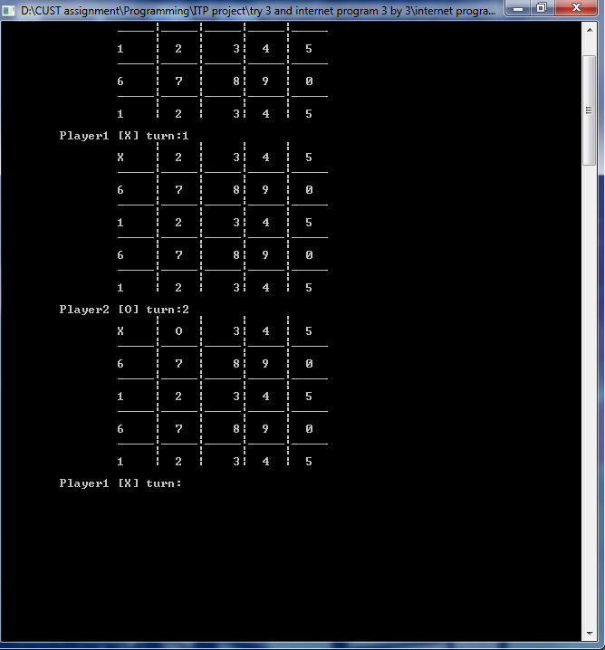

TRY 6:

#include<iostream>

using namespace std;

int main()

{

int choice, k;

int board[25] = { 0,1,2,3,4,5,6,7,8,9,10,11,12,13,14,15,16,17,18,19,20,21,22,23,24 };

/*for (int i = 0; i < 25; i++)

{

cout << endl;

cout << board[i];

}*/

cout << "\tTick Cross Game";

cout << "\n\tPlayer1 [X] \n\tPlayer2 [0]\n\n";

for (k = 1; k <= 24; k++)

{

cout << "\t\t | | | |\n";

cout << "\t\t" << board[0] << " |" << "\t" << board[1] << " |" << "\t" << board[2] << "|" << " " << board[3] << " | " << board[4] << "\n";

cout << "\t\t_____|_____|_____|_____|_____\n";

cout << "\t\t | | | |\n";

cout << "\t\t" << board[5] << " |" << "\t" << board[6] << " |" << "\t" << board[7] << "|" << " " << board[8] << " | " << board[9] << "\n";

cout << "\t\t_____|_____|_____|_____|_____\n";

cout << "\t\t | | | |\n";

cout << "\t\t" << board[10] << " |" << "\t" << board[11] << " |" << "\t\b" << board[12] << "|" << " " << board[13] << " | " << board[14] << "\n";

cout << "\t\t_____|_____|_____|_____|_____\n";

cout << "\t\t | | | |\n";

cout << "\t\t" << board[15] << " |" << "\t" << board[16] << " |" << "\t\b" << board[17] << "|" << " " << board[18] << " | " << board[19] << "\n";

cout << "\t\t_____|_____|_____|_____|_____\n";

cout << "\t\t | | | |\n";

cout << "\t\t" << board[20] << " |" << "\t" << board[21] << " |" << "\t\b" << board[22] << "|" << " " << board[23] << " | " << board[24] << "\n";

cout << "\t\t | | | |\n";

cout << "\n\tPlayer1 [X] turn:";

cin >> choice;

if (k == 24)

exit(0);

switch (choice)

{

case 1:

board[0] = 'X';

break;

case 2:

board[1] = 'X';

cout << char(88) << board[1];

break;

case 3:

board[2] = 'X';

break;

case 4:

board[3] = 'X';

break;

case 5:

board[4] = 'X';

break;

case 6:

board[5] = 'X';

break;

case 7:

board[6] = 'X';

break;

case 8:

board[7] = 'X';

break;

case 9:

board[8] = 'X';

break;

case 10:

board[9] = 'X';

break;

case 11:

board[10] = 'X';

break;

case 12:

board[11] = 'X';

break;

case 13:

board[12] = 'X';

break;

case 14:

board[13] = 'X';

break;

case 15:

board[14] = 'X';

break;

case 16:

board[15] = 'X';

break;

case 17:

board[16] = 'X';

break;

case 18:

board[17] = 'X';

break;

case 19:

board[18] = 'X';

break;

case 20:

board[19] = 'X';

break;

case 21:

board[20] = 'X';

break;

case 22:

board[21] = 'X';

break;

case 23:

board[22] = 'X';

break;

case 24:

board[23] = 'X';

break;

case 25:

board[24] = 'X';

break;

default:

cout << "\nInvalid number";

break;

}

/* system("CLS");*/

cout << "\t\t | | | |\n";

cout << "\t\t" <<static_cast<char>( board[0]) << " |" << "\t" <<static_cast<char> (board[1]) << " |" << "\t" <<static_cast<char>( board[2] )<< "|" << " " << static_cast<char>(board[3]) << " | " << static_cast<char>(board[4]) << "\n";

cout << "\t\t_____|_____|_____|_____|_____\n";

cout << "\t\t | | | |\n";

cout << "\t\t" << static_cast<char>(board[5]) << " |" << "\t" << static_cast<char> (board[6]) << " |" << "\t" << static_cast<char>(board[7]) << "|" << " " << static_cast<char>(board[8]) << " | " << static_cast<char>(board[9]) << "\n";

cout << "\t\t_____|_____|_____|_____|_____\n";

cout << "\t\t | | | |\n";

cout << "\t\t" << static_cast<char>(board[10]) << " |" << "\t" << static_cast<char> (board[11]) << " |" << "\t" << static_cast<char>(board[12]) << "|" << " " << static_cast<char>(board[13]) << " | " << static_cast<char>(board[14]) << "\n";

cout << "\t\t_____|_____|_____|_____|_____\n";

cout << "\t\t | | | |\n";

cout << "\t\t" << static_cast<char>(board[15]) << " |" << "\t" << static_cast<char> (board[16]) << " |" << "\t" << static_cast<char>(board[17]) << "|" << " " << static_cast<char>(board[18]) << " | " << static_cast<char>(board[19]) << "\n";

cout << "\t\t_____|_____|_____|_____|_____\n";

cout << "\t\t | | | |\n";

cout << "\t\t" << static_cast<char>(board[20]) << " |" << "\t" << static_cast<char> (board[21]) << " |" << "\t" << static_cast<char>(board[22]) << "|" << " " << static_cast<char>(board[23]) << " | " << static_cast<char>(board[24]) << "\n";

cout << "\t\t | | | |\n";

cout << "\n\tPlayer2 [O] turn:";

cin >> choice;

switch (choice)

{

case 1:

board[0] = 'O';

break;

case 2:

board[1] = 'O';

break;

case 3:

board[2] = 'O';

break;

case 4:

board[3] = 'O';

break;

case 5:

board[4] = 'O';

break;

case 6:

board[5] = 'O';

break;

case 7:

board[6] = 'O';

break;

case 8:

board[7] = 'O';

break;

case 9:

board[8] = 'O';

break;

case 10:

board[9] = 'O';

break;

case 11:

board[10] = 'O';

break;

case 12:

board[11] = 'O';

break;

case 13:

board[12] = 'O';

break;

case 14:

board[13] = 'O';

break;

case 15:

board[14] = 'O';

break;

case 16:

board[15] = 'O';

break;

case 17:

board[16] = 'O';

break;

case 18:

board[17] = 'O';

break;

case 19:

board[18] = 'O';

break;

case 20:

board[19] = 'O';

break;

case 21:

board[20] = 'O';

break;

case 22:

board[21] = 'O';

break;

case 23:

board[22] = 'O';

break;

case 24:

board[23] = 'O';

break;

case 25:

board[24] = 'O';

break;

default:

cout << "\nInvalid number";

break;

}

}

return 0;

}

OUTPUT AND ERROR OF PROGRAM:

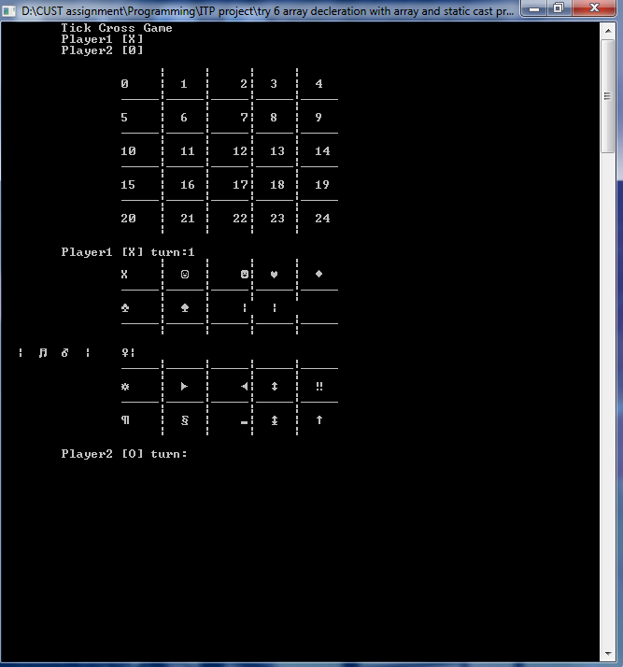

TRY 7:

#include<iostream>

#include<string.h>

using namespace std;

string board[5][5]={{"1","2","3","4","5"},{"6","7","8","9","10"},{"11","12","13","14","15"},{"16","17","18","19","20"},{"21","22","23","24","25"}};

void display_board();

void check_win();

void player_turn1();

void player_turn2();

int main()

{

int i;

while(i!=25)

{

system("COLOR 6F");

display_board();

player_turn1();

display_board();

check_win();

player_turn2();

display_board();

check_win();

}

}

void display_board()

{

system("CLS");

cout<<"\t\tTick Cross Game\n";

cout<<"\tPalyer 1 [X]\n\tPlayer 2 [O]\n";

cout<<"\t\t | | | | \n";

cout<<"\t\t "<<board[0][0] <<"| "<<board[0][1] <<"| "<<board[0][2] <<"| "<<board[0][3] <<"| "<<board[0][4] <<"\n";

cout<<"\t\t_____|_____|_____|_____|_____\n";

cout<<"\t\t | | | | \n";

cout<<"\t\t "<<board[1][0] <<"| "<<board[1][1] <<"| "<<board[1][2] <<"| "<<board[1][3] <<"| "<<board[1][4] <<"\n";

cout<<"\t\t_____|_____|_____|_____|_____\n";

cout<<"\t\t | | | | \n";

cout<<"\t\t "<<board[2][0] <<"| "<<board[2][1] <<"| "<<board[2][2] <<" | "<<board[2][3] <<" | "<<board[2][4] <<"\n";

cout<<"\t\t_____|_____|_____|_____|_____\n";

cout<<"\t\t | | | | \n";

cout<<"\t\t "<<board[3][0] <<"| "<<board[3][1] <<"| "<<board[3][2] <<" | "<<board[3][3] <<" | "<<board[3][4] <<"\n";

cout<<"\t\t_____|_____|_____|_____|_____\n";

cout<<"\t\t | | | | \n";

cout<<"\t\t "<<board[4][0] <<"| "<<board[4][1] <<"| "<<board[4][2] <<" | "<<board[4][3] <<" | "<<board[4][4] <<"\n";

cout<<"\t\t | | | | \n";

// cout<<"\n\nPlayer 1[X] Turn:";

}

void player_turn1()

{

int choice;

do{

cout<<"\nPlayer 1 [X] Turn:";

cin>>choice;

switch(choice)

{

case 1:

if(board[0][0]=="1")

board[0][0]='X';

else

{

cout<<"Invalid Choice.......\n Player 1 [X] Turn:";

player_turn1();

}

break;

case 2:

if(board[0][1]=="2")

board[0][1]='X';

else

{

cout<<"Invalid Choice.......\n Player 1 [X] Turn:";

player_turn1();

}

break;

case 3:

if(board[0][2]=="3")

board[0][2]='X';

else

{

cout<<"Invalid Choice.......\n Player 1 [X] Turn:";

player_turn1();

}

break;

case 4:

if(board[0][3]=="4")

board[0][3]='X';

else

{

cout<<"Invalid Choice.......\n Player 1 [X] Turn:";

player_turn1();

}

break;

case 5:

if(board[0][4]=="5")

board[0][4]='X';

else

{

cout<<"Invalid Choice.......\n Player 1 [X] Turn:";

player_turn1();

}

break;

case 6:

if(board[1][0]=="6")

board[1][0]='X';

else

{

cout<<"Invalid Choice.......\n Player 1 [X] Turn:";

player_turn1();

}

break;

case 7:

if(board[1][1]=="7")

board[1][1]='X';

else

{

cout<<"Invalid Choice.......\n Player 1 [X] Turn:";

player_turn1();

}

break;

case 8:

if(board[1][2]=="8")

board[1][2]='X';

else

{

cout<<"Invalid Choice.......\n Player 1 [X] Turn:";

player_turn1();

}

break;

case 9:

if(board[1][3]=="9")

board[1][3]='X';

else

{

cout<<"Invalid Choice.......\n Player 1 [X] Turn:";

player_turn1();

}

break;

case 10:

if(board[1][4]=="10")

board[1][4]='X';

else

{

cout<<"Invalid Choice.......\n Player 1 [X] Turn:";

player_turn1();

}

break;

case 11:

if(board[2][0]=="11")

board[2][0]="X ";

else

{

cout<<"Invalid Choice.......\n Player 1 [X] Turn:";

player_turn1();

}

break;

case 12:

if(board[2][1]=="12")

board[2][1]="X ";

else

{

cout<<"Invalid Choice.......\n Player 1 [X] Turn:";

player_turn1();

}

break;

case 13:

if(board[2][2]=="13")

board[2][2]="X ";

else

{

cout<<"Invalid Choice.......\n Player 1 [X] Turn:";

player_turn1();

}

break;

case 14:

if(board[2][3]=="14")

board[2][3]="X ";

else

{

cout<<"Invalid Choice.......\n Player 1 [X] Turn:";

player_turn1();

}

break;

case 15:

if(board[2][4]=="15")

board[2][4]="X ";

else

{

cout<<"Invalid Choice.......\n Player 1 [X] Turn:";

player_turn1();

}

break;

case 16:

if(board[3][0]=="16")

board[3][0]="X ";

else

{

cout<<"Invalid Choice.......\n Player 1 [X] Turn:";

player_turn1();

}

break;

case 17:

if(board[3][1]=="17")

board[3][1]="X ";

else

{

cout<<"Invalid Choice.......\n Player 1 [X] Turn:";

player_turn1();

}

break;

case 18:

if(board[3][2]=="18")

board[3][2]="X ";

else

{

cout<<"Invalid Choice.......\n Player 1 [X] Turn:";

player_turn1();

}

break;

case 19:

if(board[3][3]=="19")

board[3][3]="X ";

else

{

cout<<"Invalid Choice.......\n Player 1 [X] Turn:";

player_turn1();

}

break;

case 20:

if(board[3][4]=="20")

board[3][4]="X ";

else

{

cout<<"Invalid Choice.......\n Player 1 [X] Turn:";

player_turn1();

}

break;

case 21:

if(board[4][0]=="21")

board[4][0]="X ";

else

{

cout<<"Invalid Choice.......\n Player 1 [X] Turn:";

player_turn1();

}

break;

case 22:

if(board[4][1]=="22")

board[4][1]="X ";

else

{

cout<<"Invalid Choice.......\n Player 1 [X] Turn:";

player_turn1();

}

break;

case 23:

if(board[4][2]=="23")

board[4][2]="X ";

else

{

cout<<"Invalid Choice.......\n Player 1 [X] Turn:";

player_turn1();

}

break;

case 24:

if(board[4][3]=="24")

board[4][3]="X ";

else

{

cout<<"Invalid Choice.......\n Player 1 [X] Turn:";

player_turn1();

}

break;

case 25:

if(board[4][3]=="25")

board[4][4]="X ";

else

{

cout<<"Invalid Choice.......\n Player 1 [X] Turn:";

player_turn1();

}

break;

default:

cout<<"\nInvalid Choice.......";

break;

}

}while(choice>25||choice<1);

}

void player_turn2()

{

int choice;

do{

cout<<"\nPlayer 2 [O] Turn:";

cin>>choice;

switch(choice)

{

case 1:

if(board[0][0]=="1")

board[0][0]='O';

else

{

cout<<"Invalid Choice.......\n Player 1 [X] Turn:";

player_turn2();

}

break;

case 2:

if(board[0][1]=="2")

board[0][1]='O';

else

{

cout<<"Invalid Choice.......\n Player 1 [X] Turn:";

player_turn2();

}

break;

case 3:

if(board[0][2]=="3")

board[0][2]='O';

else

{

cout<<"Invalid Choice.......\n Player 1 [X] Turn:";

player_turn2();

}

break;

case 4:

if(board[0][3]=="4")

board[0][3]='O';

else

{

cout<<"Invalid Choice.......\n Player 1 [X] Turn:";

player_turn2();

}

break;

case 5:

if(board[0][4]=="5")

board[0][4]='O';

else

{

cout<<"Invalid Choice.......\n Player 1 [X] Turn:";

player_turn2();

}

break;

case 6:

if(board[1][0]=="6")

board[1][0]='O';

else

{

cout<<"Invalid Choice.......\n Player 1 [X] Turn:";

player_turn2();

}

break;

case 7:

if(board[1][1]=="7")

board[1][1]='O';

else

{

cout<<"Invalid Choice.......\n Player 1 [X] Turn:";

player_turn2();

}

break;

case 8:

if(board[1][2]=="8")

board[1][2]='O';

else

{

cout<<"Invalid Choice.......\n Player 1 [X] Turn:";

player_turn2();

}

break;

case 9:

if(board[1][3]=="9")

board[1][3]='O';

else

{

cout<<"Invalid Choice.......\n Player 1 [X] Turn:";

player_turn2();

}

break;

case 10:

if(board[1][4]=="10")

board[1][4]='O';

else

{

cout<<"Invalid Choice.......\n Player 1 [X] Turn:";

player_turn2();

}

break;

case 11:

if(board[2][0]=="11")

board[2][0]="O ";

else

{

cout<<"Invalid Choice.......\n Player 1 [X] Turn:";

player_turn2();

}

break;

case 12:

if(board[2][1]=="12")

board[2][1]="O ";

else

{

cout<<"Invalid Choice.......\n Player 1 [X] Turn:";

player_turn2();

}

break;

case 13:

if(board[2][2]=="13")

board[2][2]="O ";

else

{

cout<<"Invalid Choice.......\n Player 1 [X] Turn:";

player_turn2();

}

break;

case 14:

if(board[2][3]=="14")

board[2][3]="O ";

else

{

cout<<"Invalid Choice.......\n Player 1 [X] Turn:";

player_turn2();

}

break;

case 15:

if(board[2][4]=="15")

board[2][4]="O ";

else

{

cout<<"Invalid Choice.......\n Player 1 [X] Turn:";

player_turn2();

}

break;

case 16:

if(board[3][0]=="16")

board[3][0]="O ";

else

{

cout<<"Invalid Choice.......\n Player 1 [X] Turn:";

player_turn2();

}

break;

case 17:

if(board[3][1]=="17")

board[3][1]="O ";

else

{

cout<<"Invalid Choice.......\n Player 1 [X] Turn:";

player_turn2();

}

break;

case 18:

if(board[3][2]=="18")

board[3][2]="O ";

else

{

cout<<"Invalid Choice.......\n Player 1 [X] Turn:";

player_turn2();

}

break;

case 19:

if(board[3][3]=="19")

board[3][3]="O ";

else

{

cout<<"Invalid Choice.......\n Player 1 [X] Turn:";

player_turn2();

}

break;

case 20:

if(board[3][4]=="20")

board[3][4]="O ";

else

{

cout<<"Invalid Choice.......\n Player 1 [X] Turn:";

player_turn2();

}

break;

case 21:

if(board[4][0]=="21")

board[4][0]="O ";

else

{

cout<<"Invalid Choice.......\n Player 1 [X] Turn:";

player_turn2();

}

break;

case 22:

if(board[4][1]=="22")

board[4][1]="O ";

else

{

cout<<"Invalid Choice.......\n Player 1 [X] Turn:";

player_turn2();

}

break;

case 23:

if(board[4][2]=="23")

board[4][2]="O ";

else

{

cout<<"Invalid Choice.......\n Player 1 [X] Turn:";

player_turn2();

}

break;

case 24:

if(board[4][3]=="24")

board[4][3]="O ";

else

{

cout<<"Invalid Choice.......\n Player 1 [X] Turn:";

player_turn2();

}

break;

case 25:

if(board[4][3]=="25")

board[4][4]="O ";

else

{

cout<<"Invalid Choice.......\n Player 1 [X] Turn:";

player_turn2();

}

break;

default:

cout<<"\nInvalid Choice.......";

break;

}

}while(choice>25||choice<1);

}

void check_win()

{

if((board[0][0]=="X")&&(board[0][1]=="X")&&(board[0][2]=="X")&&(board[0][3]=="X")&&(board[0][4]=="X"))

{

cout<<"\nPlayer 1 wins congurats........";

exit(0);

}

if((board[1][0]=="X")&&(board[1][1]=="X")&&(board[1][2]=="X")&&(board[1][3]=="X")&&(board[1][4]=="X"))

{

cout<<"\nPlayer 1 wins congurats........";

exit(0);

}

if((board[2][0]=="X ")&&(board[2][1]=="X ")&&(board[2][2]=="X ")&&(board[2][3]=="X ")&&(board[2][4]=="X "))

{

cout<<"\nPlayer 1 wins congurats........";

exit(0);

}

if((board[3][0]=="X ")&&(board[3][1]=="X ")&&(board[3][2]=="X ")&&(board[3][3]=="X ")&&(board[3][4]=="X "))

{

cout<<"\nPlayer 1 wins congurats........";

exit(0);

}

if((board[4][0]=="X ")&&(board[4][1]=="X ")&&(board[4][2]=="X ")&&(board[4][3]=="X ")&&(board[4][4]=="X "))

{

cout<<"\nPlayer 1 wins congurats........";

exit(0);

}

if((board[0][0]=="X")&&(board[1][1]=="X")&&(board[2][2]=="X ")&&(board[3][3]=="X ")&&(board[4][4]=="X "))

{

cout<<"\nPlayer 1 wins congurats........";

exit(0);

}

if((board[0][4]=="X")&&(board[1][3]=="X")&&(board[2][2]=="X ")&&(board[3][1]=="X ")&&(board[4][0]=="X "))

{

cout<<"\nPlayer 1 wins congurats........";

exit(0);

}

if((board[0][0]=="X")&&(board[1][0]=="X")&&(board[2][0]=="X ")&&(board[3][0]=="X ")&&(board[4][0]=="X "))

{

cout<<"\nPlayer 1 wins congurats........";

exit(0);

}

if((board[0][1]=="X")&&(board[1][1]=="X")&&(board[2][1]=="X ")&&(board[3][1]=="X ")&&(board[4][1]=="X "))

{

cout<<"\nPlayer 1 wins congurats........";

exit(0);

}

if((board[0][2]=="X")&&(board[1][2]=="X")&&(board[2][2]=="X ")&&(board[3][2]=="X ")&&(board[4][2]=="X "))

{

cout<<"\nPlayer 1 wins congurats........";

exit(0);

}

if((board[0][3]=="X ")&&(board[1][3]=="X ")&&(board[2][3]=="X ")&&(board[3][3]=="X ")&&(board[4][3]=="X "))

{

cout<<"\nPlayer 1 wins congurats........";

exit(0);

}

if((board[0][4]=="X")&&(board[1][4]=="X")&&(board[2][4]=="X ")&&(board[3][4]=="X ")&&(board[4][4]=="X "))

{

cout<<"\nPlayer 1 wins congurats........";

exit(0);

}

if((board[0][0]=="O")&&(board[0][1]=="O")&&(board[0][2]=="O")&&(board[0][3]=="O")&&(board[0][4]=="O"))

{

cout<<"\nPlayer 2 wins congurats........";

exit(0);

}

if((board[1][0]=="O")&&(board[1][1]=="O")&&(board[1][2]=="O")&&(board[1][3]=="O")&&(board[1][4]=="O"))

{

cout<<"\nPlayer 2 wins congurats........";

exit(0);

}

if((board[2][0]=="O ")&&(board[2][1]=="O ")&&(board[2][2]=="O ")&&(board[2][3]=="O ")&&(board[2][4]=="O "))

{

cout<<"\nPlayer 2 wins congurats........";

exit(0);

}

if((board[3][0]=="O ")&&(board[3][1]=="O ")&&(board[3][2]=="O ")&&(board[3][3]=="O ")&&(board[3][4]=="O "))

{

cout<<"\nPlayer 2 wins congurats........";

exit(0);

}

if((board[4][0]=="O ")&&(board[4][1]=="O ")&&(board[4][2]=="O ")&&(board[4][3]=="O ")&&(board[4][4]=="O "))

{

cout<<"\nPlayer 2 wins congurats........";

exit(0);

}

if((board[0][0]=="O")&&(board[1][1]=="O")&&(board[2][2]=="O ")&&(board[3][3]=="O ")&&(board[4][4]=="O "))

{

cout<<"\nPlayer 2 wins congurats........";

exit(0);

}

if((board[0][4]=="O")&&(board[1][3]=="O")&&(board[2][2]=="O ")&&(board[3][1]=="O ")&&(board[4][0]=="O "))

{

cout<<"\nPlayer 2 wins congurats........";

exit(0);

}

if((board[0][0]=="O")&&(board[1][0]=="O")&&(board[2][0]=="O ")&&(board[3][0]=="O ")&&(board[4][0]=="O "))

{

cout<<"\nPlayer 2 wins congurats........";

exit(0);

}

if((board[0][1]=="O")&&(board[1][1]=="O")&&(board[2][1]=="O ")&&(board[3][1]=="O ")&&(board[4][1]=="O "))

{

cout<<"\nPlayer 2 wins congurats........";

exit(0);

}

if((board[0][2]=="O")&&(board[1][2]=="O")&&(board[2][2]=="O ")&&(board[3][2]=="O ")&&(board[4][2]=="O "))

{

cout<<"\nPlayer 2 wins congurats........";

exit(0);

}

if((board[0][3]=="O ")&&(board[1][3]=="O ")&&(board[2][3]=="O ")&&(board[3][3]=="O ")&&(board[4][3]=="O "))

{

cout<<"\nPlayer 2 wins congurats........";

exit(0);

}

if((board[0][4]=="O")&&(board[1][4]=="O")&&(board[2][4]=="O ")&&(board[3][4]=="O ")&&(board[4][4]=="O "))

{

cout<<"\nPlayer 2 wins congurats........";

exit(0);

}

}

OUTPUT OF THIS PROGRAM : 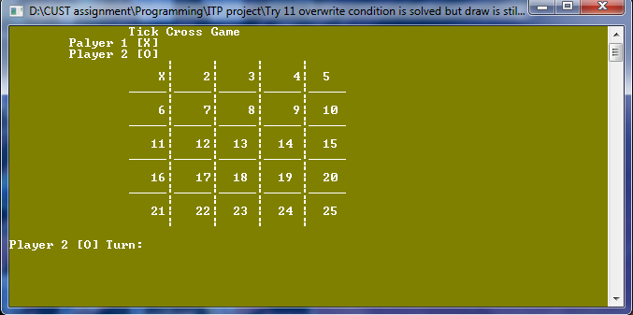

TRY 8:

#include<iostream>

#include"string"

using namespace std;

int main()

{

int choice, k;

int board[25] = { 0,1,2,3,4,5,6,7,8,9,10,11,12,13,14,15,16,17,18,19,20,21,22,23,24};

//for (int i = 0; i < 25; i++)

//{

// cout << endl;

// cout << board[i];

//}

cout << "\tTick Cross Game";

cout << "\n\tPlayer1 [X] \n\tPlayer2 [0]\n\n";

for (k = 1; k <= 24; k++)

{

cout << "\t\t | | | |\n";

cout << "\t\t" << board[0] << " |" << "\t" << board[1] << " |" << "\t" << board[2] << "|" << " " << board[3] << " | " << board[4] << "\n";

cout << "\t\t_____|_____|_____|_____|_____\n";

cout << "\t\t | | | |\n";

cout << "\t\t" << board[5] << " |" << "\t" << board[6] << " |" << "\t" << board[7] << "|" << " " << board[8] << " | " << board[9] << "\n";

cout << "\t\t_____|_____|_____|_____|_____\n";

cout << "\t\t | | | |\n";

cout << "\t\t" << board[10] << " |" << "\t" << board[11] << " |" << "\t\b" << board[12]<< "|" << " " << board[13] << " | " << board[14] << "\n";

cout << "\t\t_____|_____|_____|_____|_____\n";

cout << "\t\t | | | |\n";

cout << "\t\t" << board[15] << " |" << "\t" << board[16] << " |" << "\t\b" << board[17] << "|" << " " << board[18] << " | " << board[19]<< "\n";

cout << "\t\t_____|_____|_____|_____|_____\n";

cout << "\t\t | | | |\n";

cout << "\t\t" << board[20] << " |" << "\t" << board[21] << " |" << "\t\b" << board[22] << "|" << " " << board[23] << " | " << board[24] << "\n";

cout << "\t\t | | | |\n";

cout << "\n\tPlayer1 [X] turn:";

cin >> choice;

if (k == 24)

exit(0);

switch (choice)

{

case 1:

board[0] = 'X';

break;

case 2:

board[1] = 'X';

break;

case 3:

board[2] = 'X';

break;

case 4:

board[3] = 'X';

break;

case 5:

board[4] = 'X';

break;

case 6:

board[5] = 'X';

break;

case 7:

board[6] = 'X';

break;

case 8:

board[7] = 'X';

break;

case 9:

board[8] = 'X';

break;

case 10:

board[9] = 'X';

break;

case 11:

board[10] = 'X';

break;

case 12:

board[11] = 'X';

break;

case 13:

board[12] = 'X';

break;

case 14:

board[13] = 'X';

break;

case 15:

board[14] = 'X';

break;

case 16:

board[15] = 'X';

break;

case 17:

board[16] = 'X';

break;

case 18:

board[17] = 'X';

break;

case 19:

board[18] = 'X';

break;

case 20:

board[19] = 'X';

break;

case 21:

board[20] = 'X';

break;

case 22:

board[21] = 'X';

break;

case 23:

board[22] = 'X';

break;

case 24:

board[23] = 'X';

break;

case 25:

board[24] = 'X';

break;

default:

cout << "\nInvalid number";

break;

}

cout << "\t\t | | | |\n";

cout << "\t\t" << board[0] << " |" << "\t" << board[1] << " |" << "\t" << board[2] << "|" << " " << board[3] << " | " << board[4] << "\n";

cout << "\t\t_____|_____|_____|_____|_____\n";

cout << "\t\t | | | |\n";

cout << "\t\t" << board[5] << " |" << "\t" << board[6] << " |" << "\t" << board[7] << "|" << " " << board[8] << " | " << board[9] << "\n";

cout << "\t\t_____|_____|_____|_____|_____\n";

cout << "\t\t | | | |\n";

cout << "\t\t" << board[10] << " |" << "\t" << board[11] << " |" << "\t" << board[12] << " |" << " " << board[13] << " | " << board[14] << "\n";

cout << "\t\t_____|_____|_____|_____|_____\n";

cout << "\t\t | | | |\n";

cout << "\t\t" << board[15] << " |" << "\t" << board[16] << " |" << "\t" << board[17] << "|" << " " << board[18] << " | " << board[19] << "\n";

cout << "\t\t_____|_____|_____|_____|_____\n";

cout << "\t\t | | | |\n";

cout << "\t\t" << board[20] << " |" << "\t" << board[21] << " |" << "\t" << board[22] << "|" << " " << board[23] << " | " << board[24] << "\n";

cout << "\n\tPlayer2 [O] turn:";

cin >> choice;

switch (choice)

{

case 1:

board[0] = 'O';

break;

case 2:

board[1] = 'O';

break;

case 3:

board[2] = 'O';

break;

case 4:

board[3] = 'O';

break;

case 5:

board[4] = 'O';

break;

case 6:

board[5] = 'O';

break;

case 7:

board[6] = 'O';

break;

case 8:

board[7] = 'O';

break;

case 9:

board[8] = 'O';

break;

case 10:

board[9] = 'O';

break;

case 11:

board[10] = 'O';

break;

case 12:

board[11] = 'O';

break;

case 13:

board[12] = 'O';

break;

case 14:

board[13] = 'O';

break;

case 15:

board[14] = 'O';

break;

case 16:

board[15] = 'O';

break;

case 17:

board[16] = 'O';

break;

case 18:

board[17] = 'O';

break;

case 19:

board[18] = 'O';

break;

case 20:

board[19] = 'O';

break;

case 21:

board[20] = 'O';

break;

case 22:

board[21] = 'O';

break;

case 23:

board[22] = 'O';

break;

case 24:

board[23] = 'O';

break;

case 25:

board[24] = 'O';

break;

default:

cout << "\nInvalid number";

break;

}

}

return 0;

}

OUTPUT OF THIS PROGRAM:

